Current Activities & Acquisitions
The last two months have been rather quiet on the acquisitions front. We have received an acoustic modem in excellent condition to replace the rather tired one originally on display, a partial CE toolkit in poor condition, some portable PCs and various pieces of documentation. One benefactor has kindly purchased a set of System/3 coasters on eBay and donated them to us.

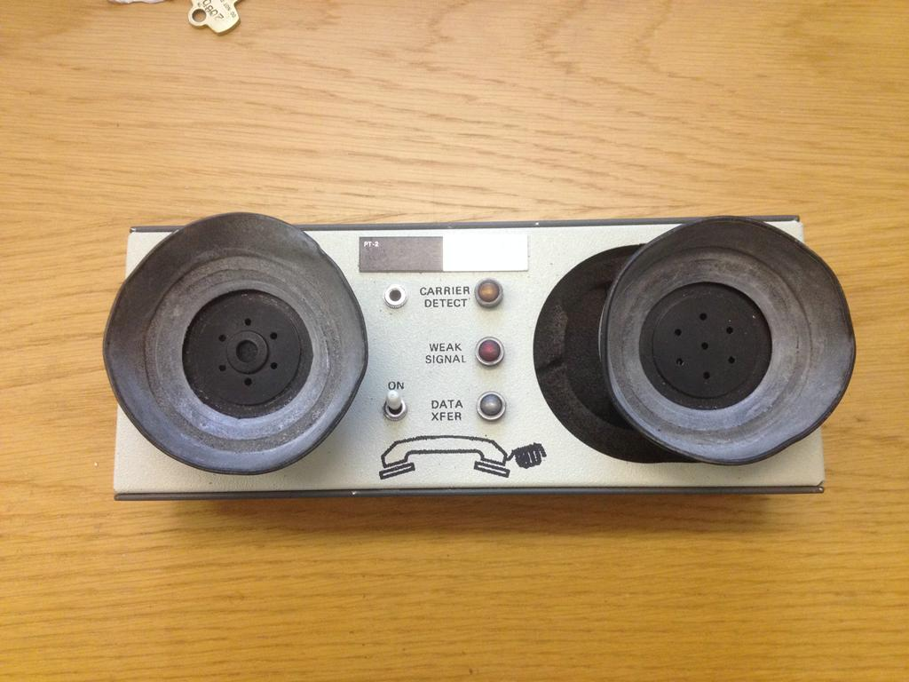
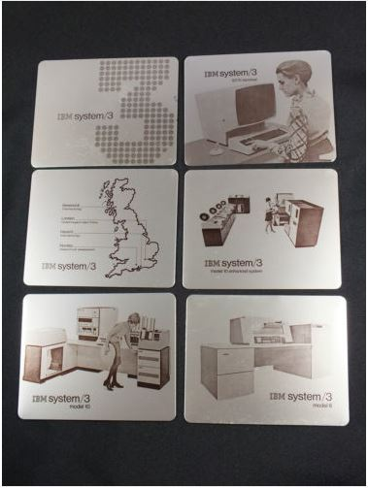

2984 CashPoint Model

We have started work on building a semi-scale full size model of the 2984 Lloyds CashPoint. We seem to have exhausted the possibility of finding a real one, so this is the next best thing! We have an original instruction plate and some photos that help us to gauge the dimensions, but we don't have any detail pictures of the keyboard area. We are also unsure of whether there was any form of display to guide users through the process, or whether they just had to follow the instructions on the metal plate, and have sent out an appeal to our retiree community for assistance.

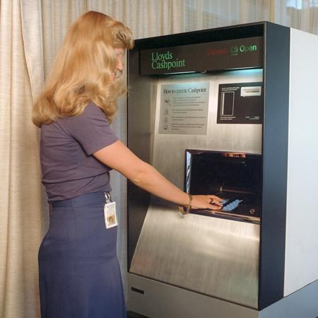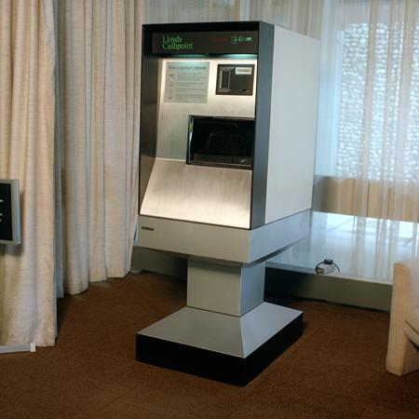

Ada Lovelace Day

Hursley ran an event for a number of schoolgirls to celebrate Ada Lovelace day. A member of staff dressed up as Ada and the girls were given a tour of the museum in between practical hands-on sessions designed to spur an interest in IT. The event was featured in the BBC South Today news programme, a copy of which can be found on the museum web site
(Links to https://www.youtube.com/watch?v=ylAEgV5t53U&feature=youtu.be)

Analogue Computer Identified

Thanks to the CCS, specifically Dik Leatherdale and Michael Brisk, we were able to identify analogue computers used by Vickers during their time at Hursley in the 1950s.

